How to use Track Changes and Comments in WORD

These commands appear under the Review tab.
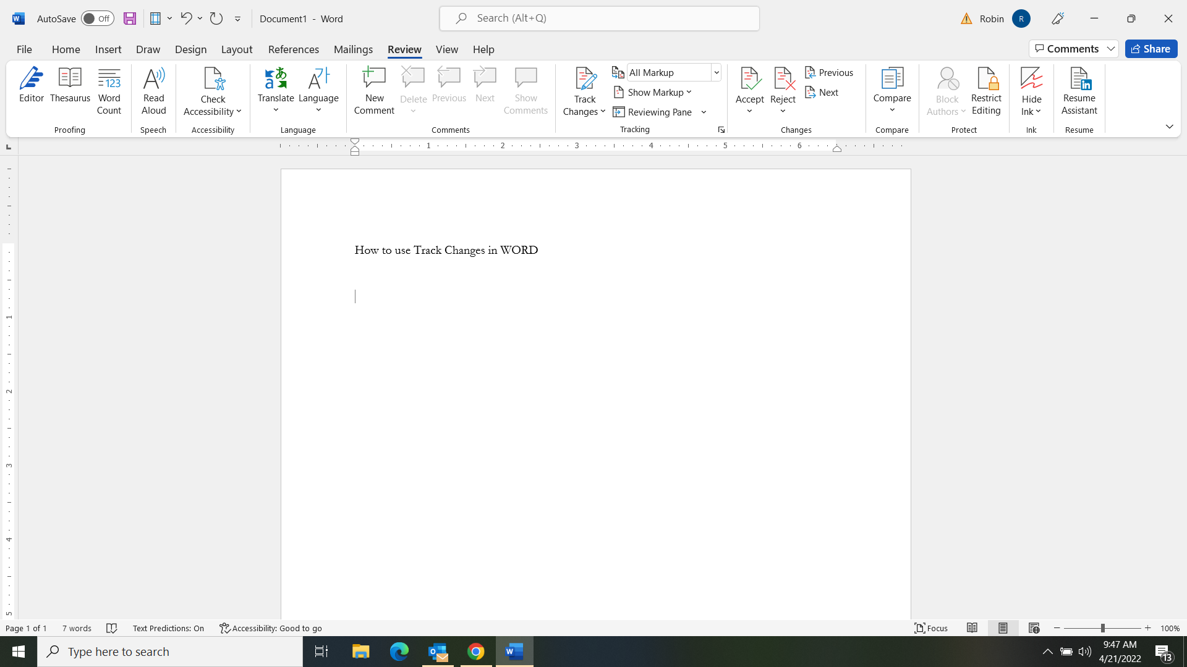

Track Changes will mark in color and with other on-screen cues when edits have been made to the text.
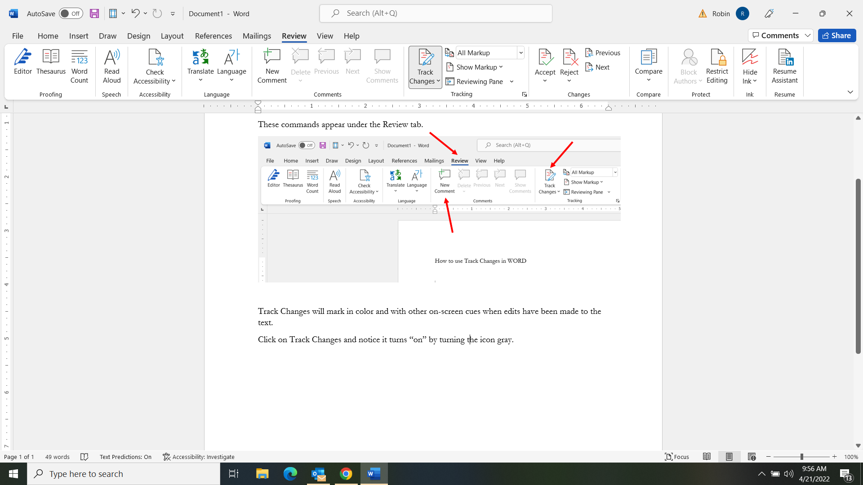
Click on Track Changes and notice it turns “on” by turning the icon gray.
Make sure it says All Markup in order to see all changes that have been made.
Click on the icon. If it’s gray, it’s “on.”

When reviewing everyone’s edits, use Accept to keep that change that has been made. Use Reject to cancel out the change and go back to the original version. Previous and Next let you skip backward or forward to the next change.

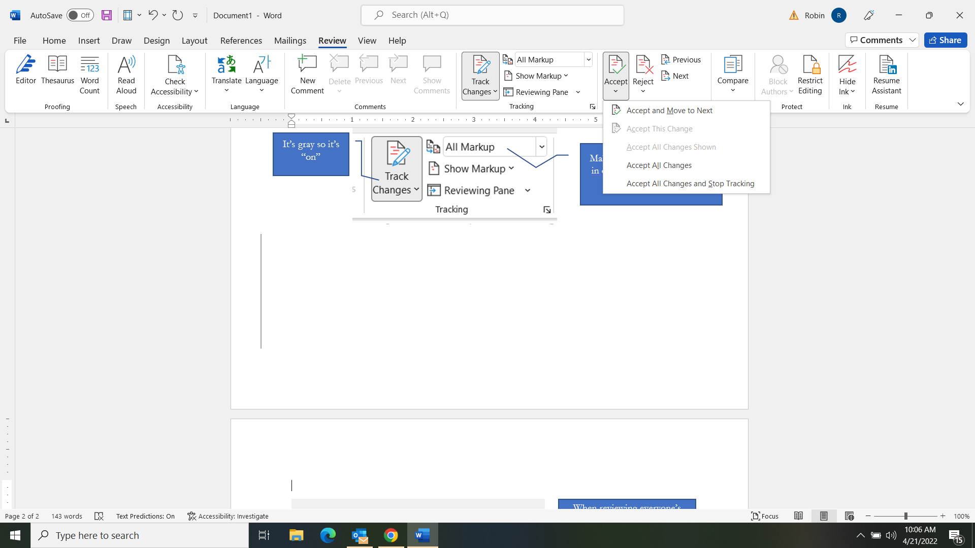
Click the arrow under Accept or Reject to get a menu of options. You can choose to have WORD perform the accept or reject command on all edits in the entire text all at one time.
NOTE: when self publishing, you MUST accept or reject all changes and turn off Track Changes before you upload the manuscript to KDP. Choose Accept [or Reject]All Changes and Stop Tracking to do this.

Compare lets you set two version of a document side-by-side to see how they may be different. It is useful when an editor did not click on Track Changes before making edits.

Comments let you make little asides or critiques that do not appear as actual changes in the text. First, highlight the passage you want to make a comment about.

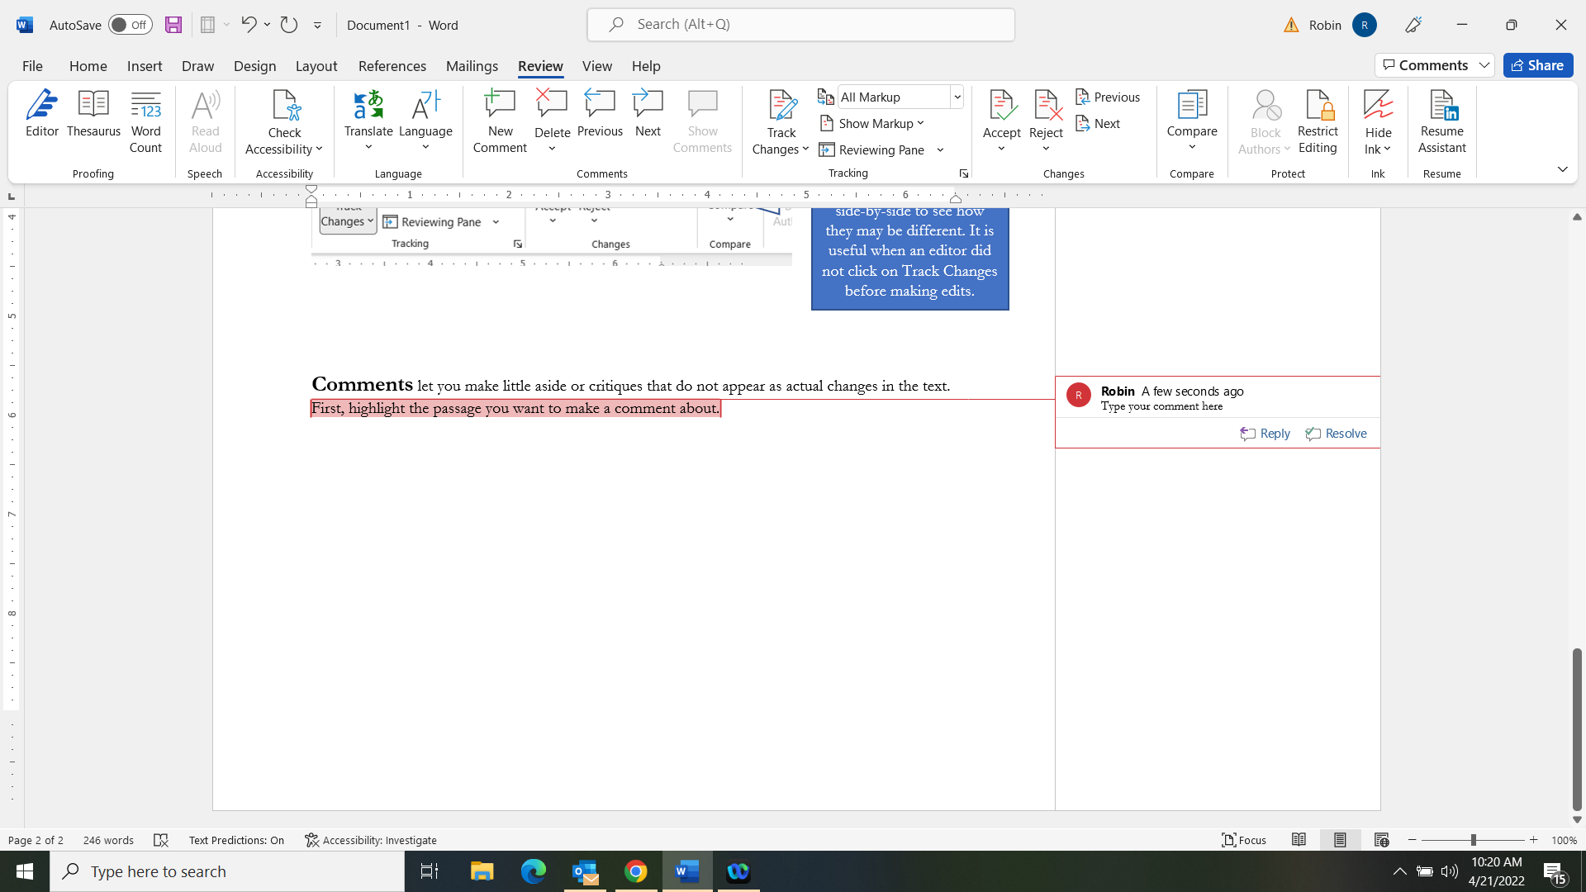
Step 3: Type your comment
Step 2: Click New Comment.
Step 1: Highlight the passage

When reviewing other people’s comments, you’ll use the Delete command to remove a comment after you’ve dealt with the issue.
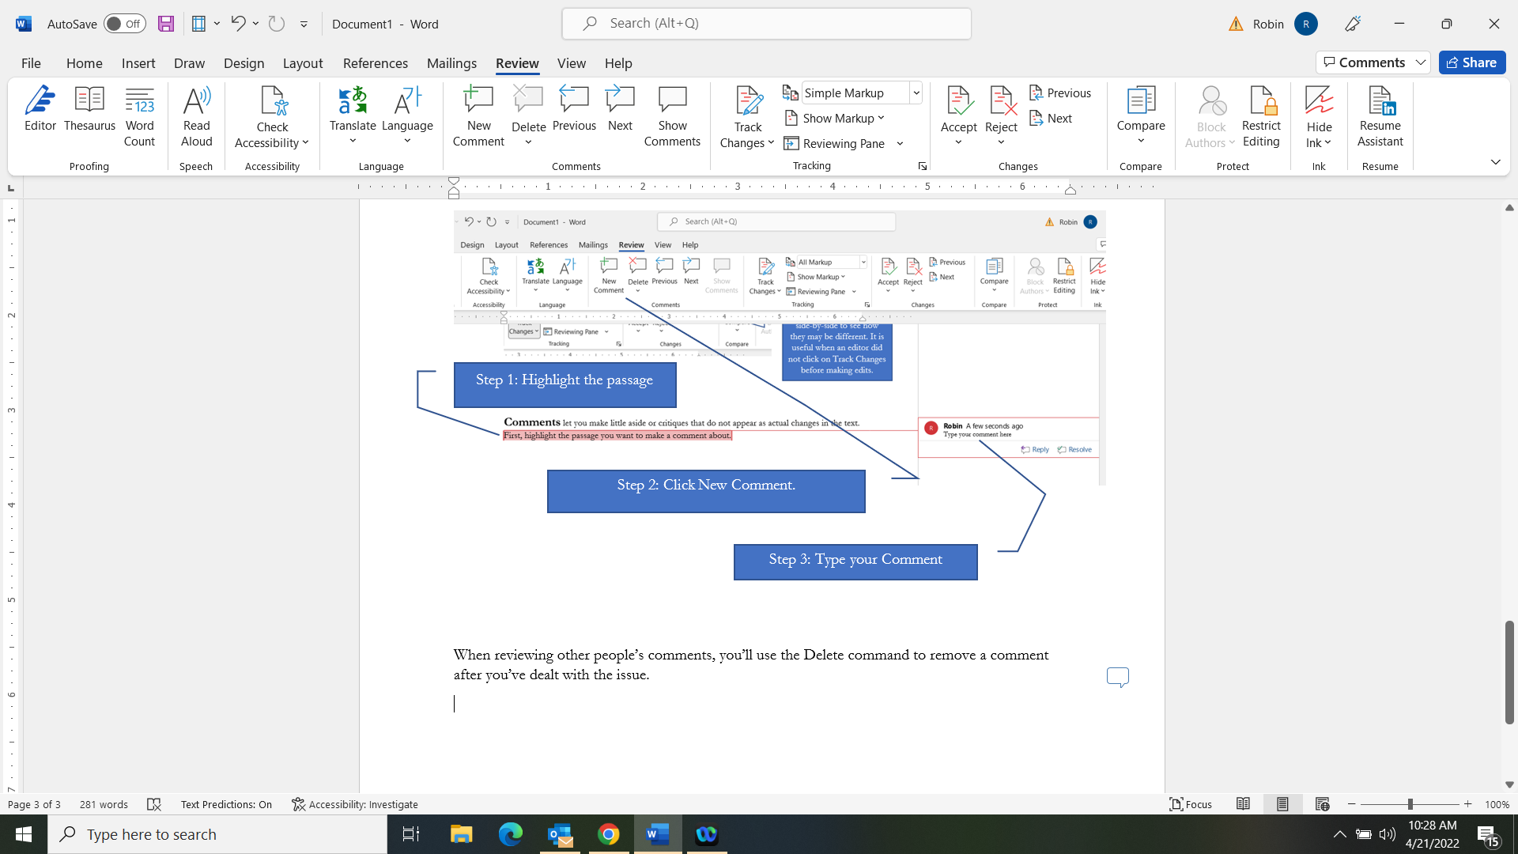
Comments should be removed through the manuscript before submitting to KDP for self-publishing. Again, you can hit the down arrow under delete to choose the option to Delete All Comments throughout the document.
When reviewing your comments, you may wonder why you can’t see them. They just appear as little bubbles on the right hand margin. This is likely because you have the document set to Simple Markup. There are three ways to fix this to be able to see the written comments.
#1: Click the arrow next to Simple Markup to change it to All Markup.
#2: Click on Show Comments.
NOTE: If this command is inactive (grayed out), then click or highlight anywhere in the text and it should activate so you can turn the feature on.
#3, Click on the individual Comment bubbles to read the comment.

